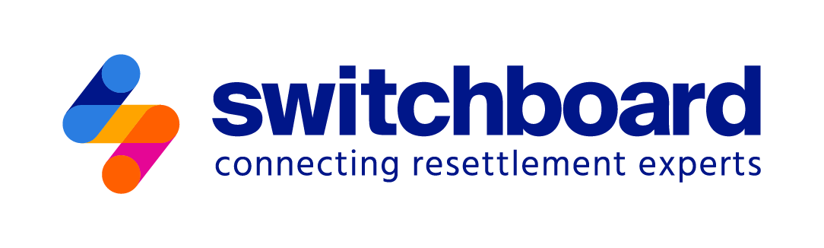

Agency Self-Assessment Tool
for Serving LGBTQ+ Newcomers

Resource Links
January 2025

The following resources provide additional information on topics that are addressed in the Agency Self-Assessment Tool for Serving LGBTQ+ Newcomers. The first matrix is populated with links to blogs, guides, webinar recordings, and other resources that are available through Switchboard. It indicates which sections of the Self-Assessment Tool are addressed by each item that is included, and is arranged by chronological order. The second matrix provides links to resources that are available through government agencies and organizations other than Switchboard.

- Public Welcome
- Community Context and Partnership Potential
- Organizational Infrastructure
- Terminology and Shared Knowledge
- Intake and Confidentiality
- Belonging and Leadership
- Partnerships
- Monitoring, Evaluation, and Continuous Improvement

Featured Resources Available Via Switchboard | Resource Types | Main Topics Addressed
 |  | 1. Public Welcome | 2. Community Context | 3. Org. Infra-  structure | 4. Term. & Knowledge | 5. Intake | 6. Belonging | 7. Partner-ships | 8. Monitoring & Eval
Responsive Services for Transgender and Gender Nonconforming (TGNC) Newcomers (December 2024) | Guide |  |  |  | x | x |  | x
Healthy Life, Healthy Body, Healthy Mind: Social Determinants of Health in LGBTQ+ Newcomers (December 2024) | Blog |  |  |  | x |  | x
Safeguarding Identity and Addressing the Legal Needs of LGBTQ+ Newcomers (September 2024) | Blog |  | x |  |  | x
How to Support Transgender and Gender Non-Conforming Newcomers (September 2024) | Blog |  |  |  | x | x |  | x
Four Steps You Can Take to Start Measuring the Success of Your Project (September 2024) | Blog |  |  |  |  |  |  |  | x
Welcoming LGBTQ+ Newcomers: Practical Tools and Tips (August 2024) | Blog | x |  |  |  |  | x | x
LGBTQ+ Responsive URM Programs and Services (July 2024) | Webinar |  |  | x | x
Creating Inclusive Spaces for the LGBTQ+ Community in Newcomer Services (June 2024) | Webinar | x |  |  | x |  | x
Proud to Welcome All: Community Education About LGBTQ+ Newcomers at Pride and World Refugee Day Events (June 2024) | Blog | x
Understanding and Serving LGBTQ+ Newcomers (May 2024) | Webinar |  | x |  | x
Navigating the Impact of Hate Incidents and Hate Crimes on Clients and Direct Service Staff (May 2024) | Blog |  | x | x
What is the Impact of Peer Support Groups on Refugees’ Mental Health? (May 2024) | Evidence summary |  |  |  |  |  | x
LGBTQ2I+ Newcomers Critical Issues (December 2023) | E-learning course |  |  | x | x
Trauma-Informed Care: A Primer for Refugee Service Providers (December 2023) | Guide |  |  | x
Training and Supporting Community Members Serving as Interpreters | Webinar |  |  |  | x
Serving LGBTQ+ Newcomers (June 2023) | Podcast |  | x |  |  |  |  | x
Introduction to Working with Interpreters (February 2023) | E-learning course |  |  |  | x
What Works to Support LGBTQ Refugees? (May 2022) | Evidence summary |  |  |  | x
Fundamentals of Equity and Resettlement: Lessons from a Panel Discussion (February 2022) | Blog |  | x
Using Participatory Methods for More Inclusive Monitoring and Evaluation (M&E) (August 2021) | Guide |  |  |  |  |  |  |  | x
How Companies Can Mentor LGBTQ Refugees (December 2020) | Guide |  |  |  |  |  |  | x
In Search of Safety: LGBTQ+ Refugee Protection and HIAS (June 2020) | Webinar |  |  | x | x
“You Are Safe Here” multilingual posters, ORAM (April 2020) | Toolkit | x
Access to Mental Health Services for Refugees and Other Vulnerable Immigrants in the U.S. (August 2019) | Guide |  |  |  |  |  |  | x
Supporting LGBT Asylum Seekers in the United States (October 2015) | Guide |  | x |  | x |  | x | x
LGBT Refugee Resettlement Guidelines and Agency Self-Assessment (October 2013) | Tool or template |  |  | x
In Our Voices: The Journeys of LGBT Refugees and Asylees (July 2013) | Video |  |  |  | x
Rainbow Response: A Practical Guide to Resettling LGBT Refugees and Asylees (October 2012) | Guide |  | x | x | x

Additional Highlighted Resources | Notes
GLAAD, the Human Rights Campaign (HRC), the National Immigrant Justice Center, Center of Excellence on LGBTQ+ Behavioral Health Equity, and RUSA LGBTQ+ | Glossaries on LGBTQ+ terminology in English, Spanish, Russian, and Arabic
InReach | National directory of service providers for LGBTQ+ people who are newcomers, BIPOC, youth, and/or caregivers
CenterLink LGBTQ Community Center Member Directory | Directory of LGBTQ+ community organizations
National LGBTQ Bar Association and Foundation | Resource for finding legal help
Directory of support groups for transgender people | Trans Lifeline
Provider Directory Search for transgender people | World Professional Association for Transgender Health
Interpreting for Gender & Sexual Diversity | Webinar, Interpretips, December 2023
The Genderbread Person | Model for understanding gender, Sam Killerman
We Shall Overcome: A Case Study of the LGBT Asylum Task Force, a Parish Ministry | Max Niedzwiecki, Clark University, March 2023
LGBTQ+ Asylum Seekers in the U.S.: Strengths, Challenges, and What it Means to “Belong” | Craig Mortley, Episcopal Migration Ministries Rainbow Initiative, June 2023
A Guide to Creating LGBTQ-Inclusive Forms | Essie Shachar-Hill, Keshet, April 2020
Corporate Equality Index 2023-2024: Rating Workplaces on Lesbian, Gay, Bisexual, Transgender, and Queer Equality | Human Rights Campaign Foundation, November 2023
LGBTQ Liaison Units: Listening, Adjusting, and Meeting Needs | U.S. Department of Justice, June 2021
Housing Discrimination and Persons Identifying as Lesbian, Gay, Bisexual, Transgender, and/or Queer/Questioning (LGBTQ) | U.S. Department of Housing and Urban Development, February 2022

The IRC received competitive funding through the U.S. Department of Health and Human Services, Administration for Children and Families, Grant #90RB0053. The project is 100% financed by federal funds. The contents of this document are solely the responsibility of the authors and do not necessarily represent the official views of the U.S. Department of Health and Human Services, Administration for Children and Families.

